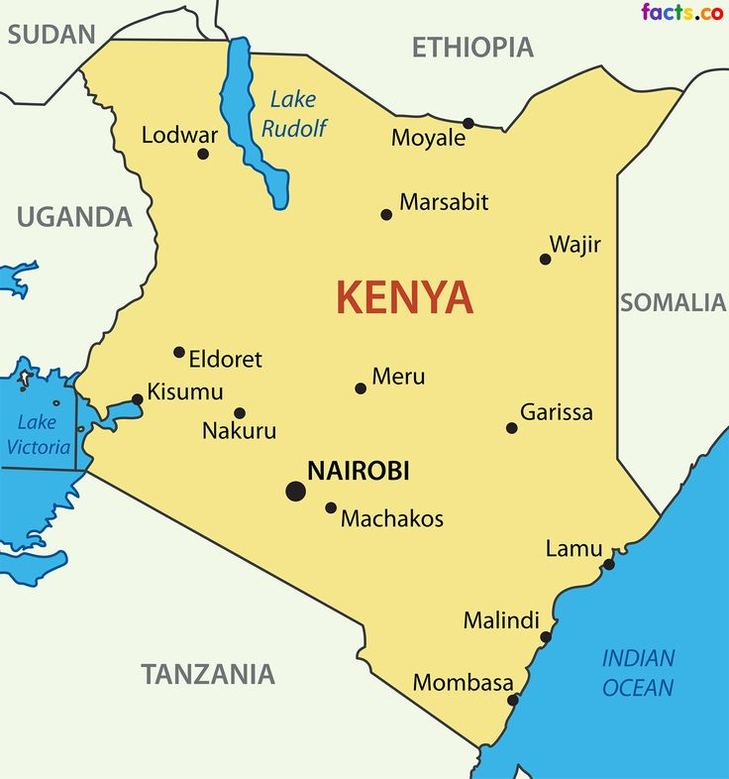
COUNTRIES NEIGHBOURING KENYA

